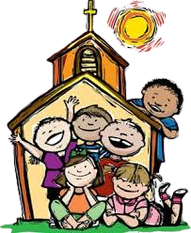
CHILDREN’S LITURGY
SCHEDULE
St. Peter’s Church
2022-2023

PREVIEW VIDEOS | IN PERSON SESSIONS | SESSION TIMES
Oct. 2 | Oct. 23 | 10:15 a.m.
Nov. 6 | Nov. 27 (First Sunday of Advent) | 10:15 a.m.
-- | Dec. 18 | 10:15 a.m.
Jan. 1 | Jan. 29 | 10:15 a.m.
Feb. 5 | Feb. 26 | 10:15 a.m.
March 5 | March 26 | 10:15 a.m.
Apr. 2 | Apr. 30 | 10:15 a.m.
May 14 | May 21 | 10:15 a.m.
June 18 | June 11 | 10:15 a.m.

